**GOVERNMENT COLLEGE OF ENGINEERING [IRTT]**

**ERODE: 638 316**



**Electronics and Communication Engineering**

**NAAN MUDHALVAN**

**DIGITAL MARKETING**

**ASSIGNMENT**

NM ID: 5BA97A43C6B53FCB78D41CF3CE83BFC0

NAME: JANANI SUSMITHA N

*BRAND NAME: SNOWBELL GELATO*

*CATEGORY: DESSERTS*

1. Create a blog or website using Blogspot and WordPress. Customize the theme design and post new article with 500 words.

Blog using blogspot:

Link:

https://snowbellgelato.blogspot.com/2023/08/gelato.html

Screenshot:

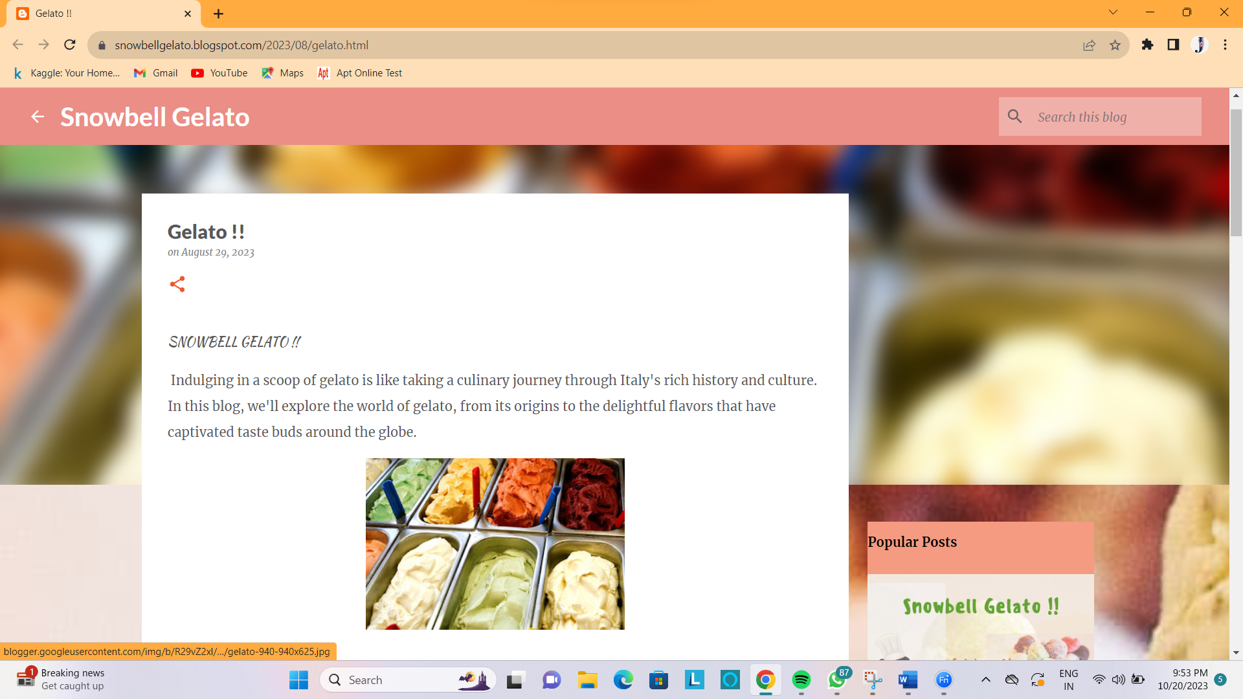

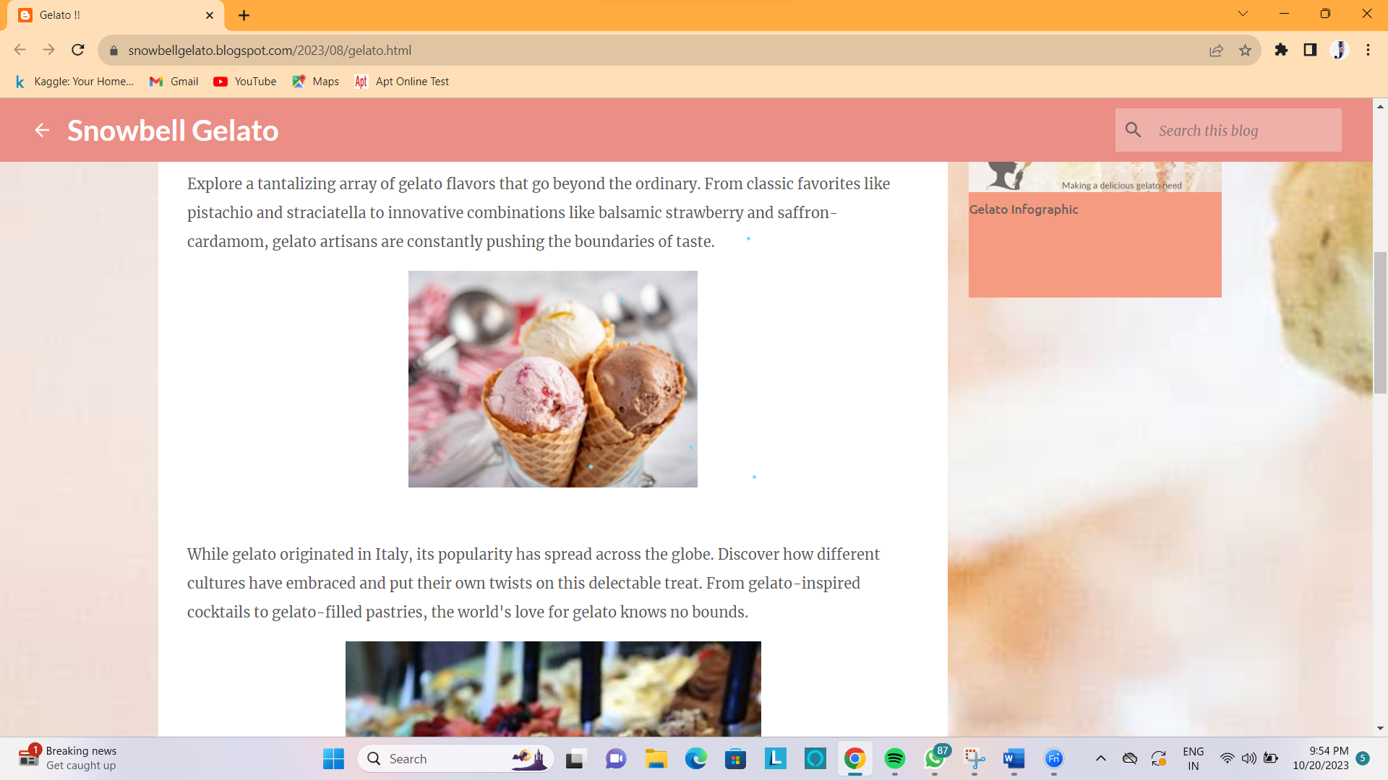

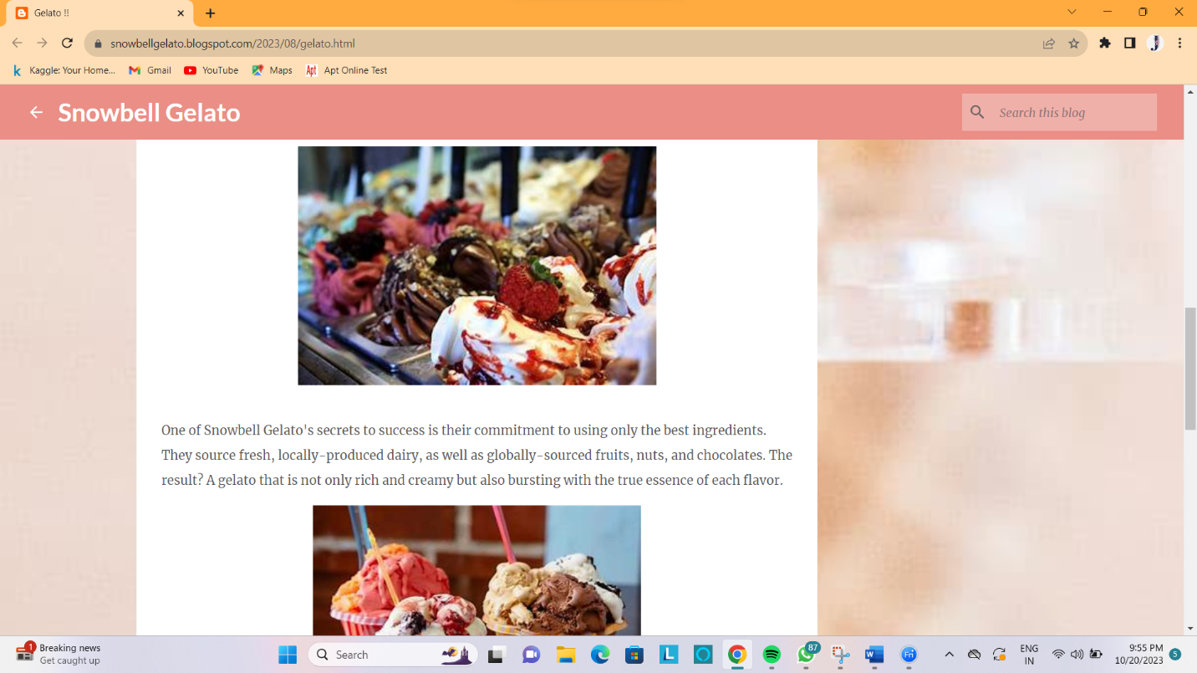

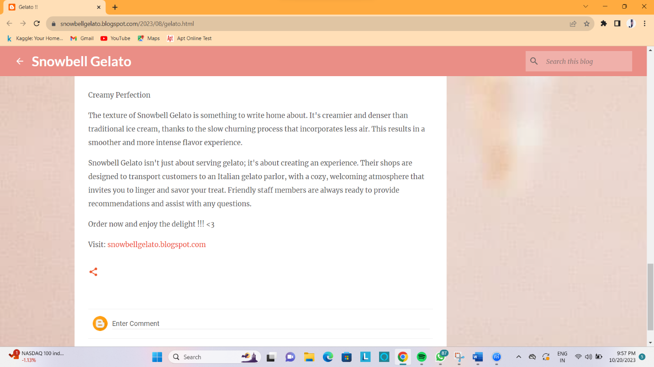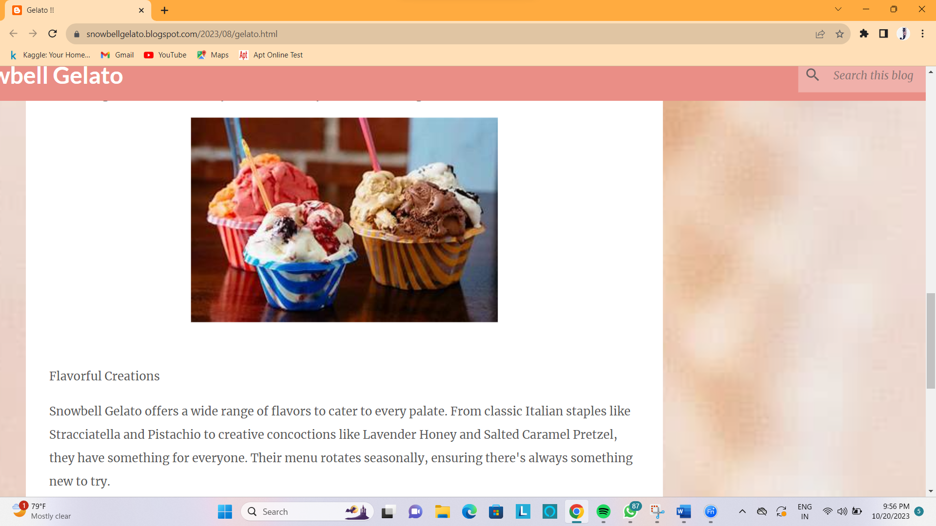

2. Create a New Facebook Business Page and post one social media poster for your brand.

Link: Facebook business page

<https://www.facebook.com/profile.php?id=61550652028743&mibextid=b06tZ0>

Screenshot:

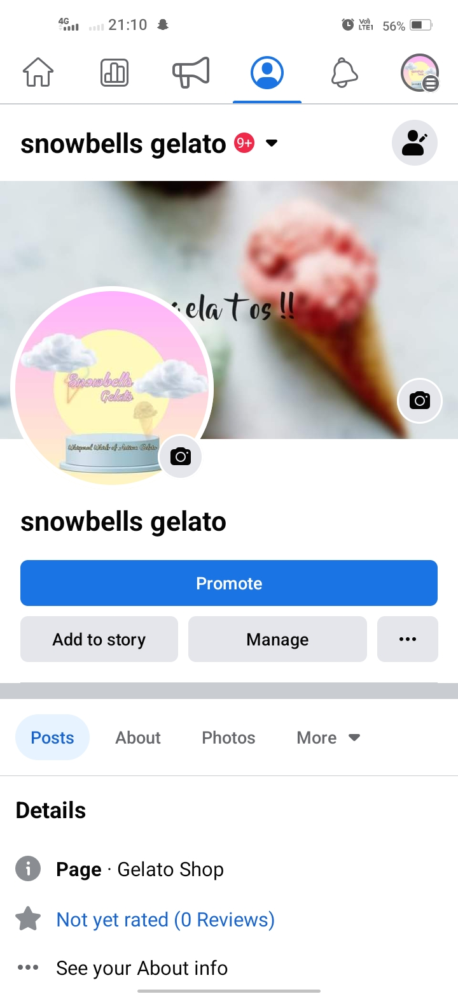

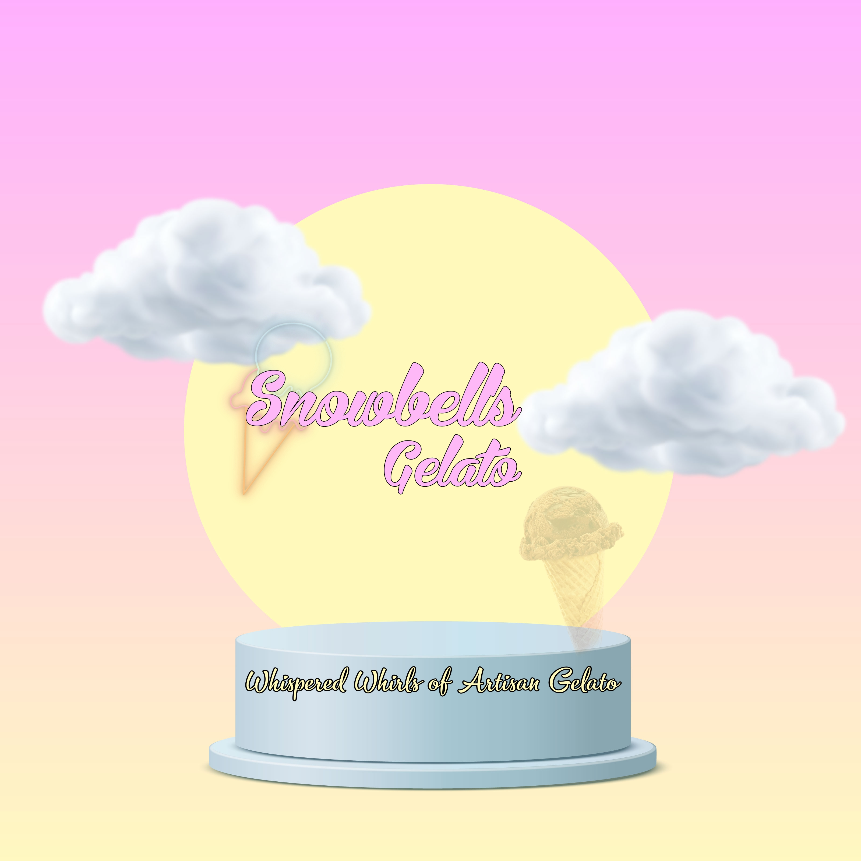

3. Create and design a social media advertisement poster

using canva.

Link:

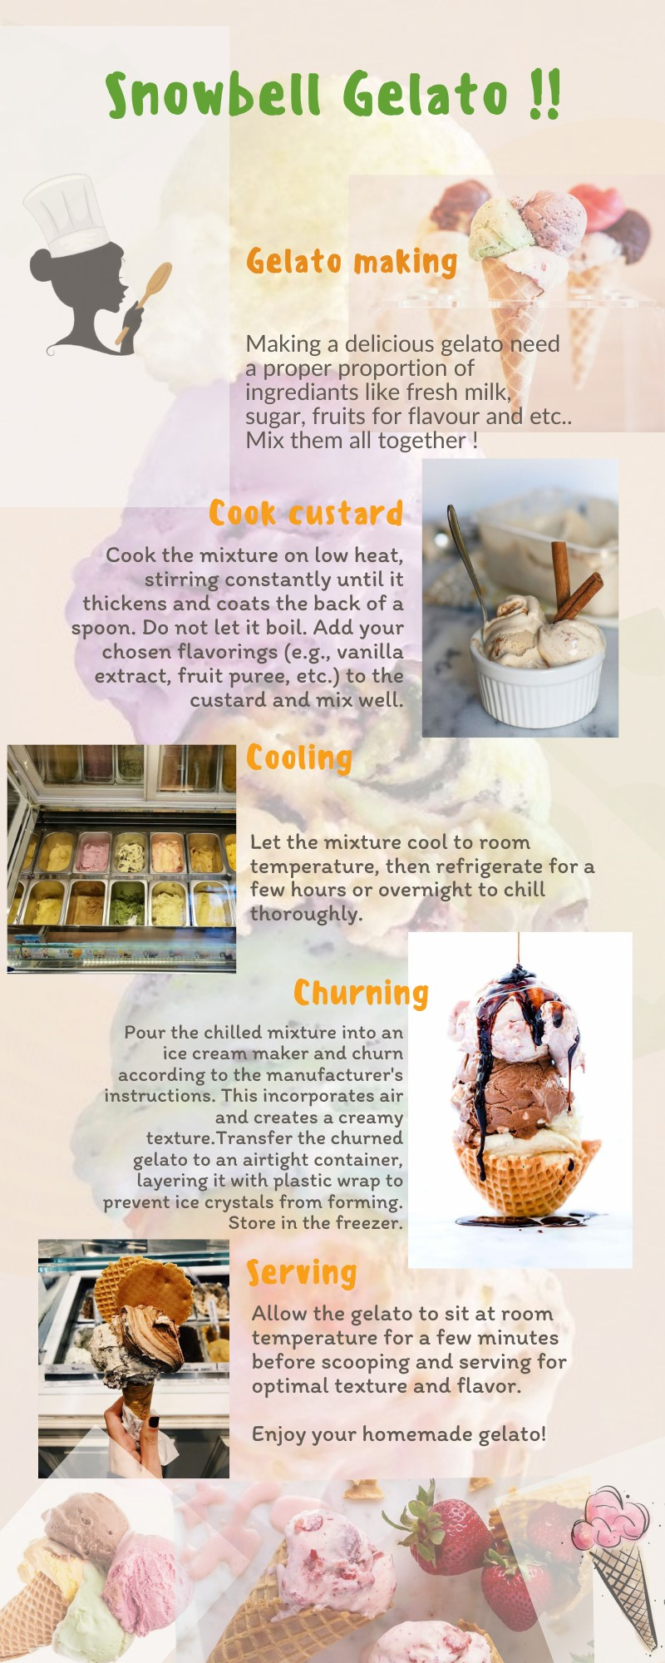<https://snowbellgelato.blogspot.com/2023/08/gelato-infographic.html>

Screenshot

4. Create email newsletter design using MailChimp or canva

tool.

Link:

<https://snowbellgelato.blogspot.com/2023/08/gelato-newsletter.html>

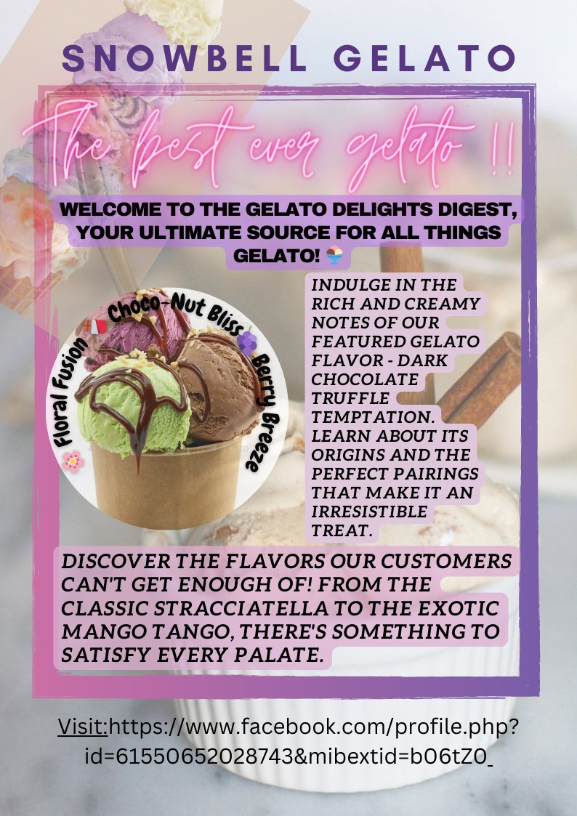Screenshot: